Year 12 Physics
Unit 4
Standard Model
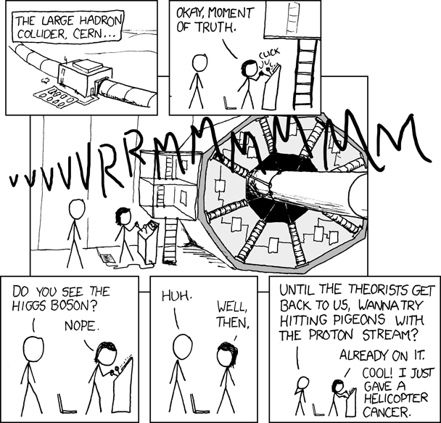

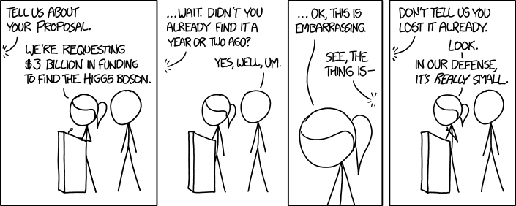

(Munroe, n.d.)

Name:
Proposed timeline

Wk | # | Topic | Practical activities | STAWA Questions | Pearson Physics
4 | 1 | Distances in space | points on balloon
4 | 2 | Expanding Universe
4 | 3 | Big Bang Theory
4 | 4 | Light and quanta topic test
4 | 5 | Evidence for the Big Bang Theory
5 | 1 | Future of the Universe
5 | 2 | Special relativity
5 | 3 | Special relativity
5 | 4 | Universe Analytical Test
5 | 5 | Special relativity
6 | 1 | Staff PL day
6 | 2 | Special relativity
6 | 3 | Special relativity
6 | 4 | Special relativity
6 | 5 | Special relativity
7 | 1 | Particle Accelerators | charged particle in magnetic field - cloud chamber
7 | 2 | Introduction to the Standard Model
7 | 3 | Introduction to the Standard Model
7 | 4 | Relativity and Universe Topic Test
7 | 5 | Antimatter
8 | 1 | Hadrons
8 | 2 | Leptons
8 | 3 | Fundamental Forces
8 | 4 | Particle Accelerators Analysis
8 | 5 | The Big Bang and the Standard Model
9 | 1 | Revision
9 | 2 | Revision
9 | 3 | Revision
9 | 4 | Standard Model Topic Test
9 | 5 | Revision
10 | 1 | Revision
10 | 2 | Revision
10 | 3 | Revision
10 | 4 | Revision
10 | 5 | Staff PL day

SCSA ATAR Syllabus
https://senior-secondary.scsa.wa.edu.au/syllabus-and-support-materials/science/physics

Science Understanding
- The expansion of the universe can be explained by Hubble’s law and cosmological concepts, such as red shift and the Big Bang theory
- The Standard Model is used to describe the evolution of forces and the creation of matter in the Big Bang theory
- High-energy particle accelerators are used to test theories of particle physics, including the Standard model
This includes deriving and applying the relationship
$$\frac{mv^{2}}{r}=qvB$$
- The Standard Model is based on the premise that all matter in the universe is made up from elementary matter particles called quarks and leptons; quarks experience the strong nuclear force, leptons do not
- The Standard Model explains three of the four fundamental forces (strong, weak and electromagnetic forces) in terms of an exchange of force-carrying particles called gauge bosons; each force is mediated by a different type of gauge boson
- Lepton number and baryon number are examples of quantities that are conserved in all reactions between particles; these conservation laws can be used to support or invalidate proposed reactions. Baryons are composite particles made up of quarks.

Science as a Human Endeavour
The Big Bang theory describes the early development of the universe, including the formation of subatomic particles from energy and the subsequent formation of atomic nuclei. There is a variety of evidence that supports the Big Bang theory, including Cosmic Background Radiation, the abundance of light elements and the red shift of light from galaxies that obey Hubble’s Law. Alternative theories exist, including the Steady State theory, but the Big Bang theory is the most widely accepted theory today.

Fleeing Stars
- Careful consideration of stellar spectra shows that the light from all distant stars is red-shifted
- It seems that all distant stars are moving away from us
- Careful measurement must be made to understand problem
- Degree of red-shift varies between stars – why?
- Is there a pattern?
- Collect more data about the stars – start with how far away they are

Cosmological distances

“Space is big. Really big. You just won't believe how vastly, hugely, mind-bogglingly big it is. I mean, you may think it's a long way down the road to the chemist, but that's just peanuts to space.”
Douglas Adams

- m and km rapidly become inadequate in space – need new units for distances in space:
  - Astronomical units
  - Lightyears
  - Parsecs (Parallax-seconds)

Astronomical units
- 1 AU = Roughly the distance from the Earth to the Sun
- 1 AU = 149597870700 m
- According to datasheet 1 AU = 1.5 x 10¹¹ m
- Normally only used within solar system

Lightyears
- 1 ly = the distance light travels in a year
- 1 ly = 1 x 365 x 24 x 60 x 60 x 3 x 10⁸
- According to datasheet 1 ly = 9.46 x 10¹² km
- Useful at larger scales, intuitive to understand

Parsecs (Parallax seconds)
- 1 pc = Distance at which 1 AU subtends and angle of 1 arcsecond (1/3600 of a degree)
- According to datasheet 1 pc = 3.26 ly
- Inherently related to the method we use to measure the distance to near stars but difficult to understand
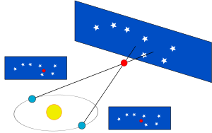

Examples
How far is a light minute in km?

How far is a light second in km?

Alpha Centauri A and B are roughly 4.37 ly away, how many parsecs is this?

How long would it take a spaceship travelling at 0.1c to reach Alpha Centauri?

Red-shift
- The stellar spectra of all distant stars appear red-shifted
- Can be modelled using the doppler effect for closer distant stars (for more distant stars must account for expansion of space and general relativity)
- Doppler effect: a wave source moving relative to an observer creates waves of relatively longer wavelength when receding and relatively shorter wavelength when approaching
- The degree of red-shift is determined by the relative velocity between the observer and the wavesource
$$v=\frac{∆λ}{λ}c$$

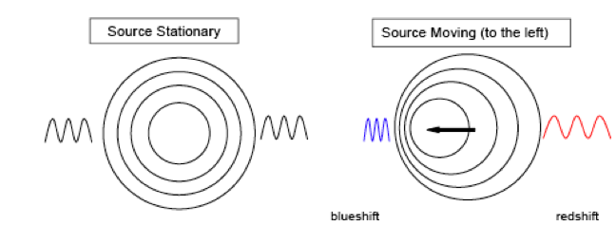

Example
- A star is observed to have an ionised atmosphere of helium. The characteristic wavelength of a certain absorption line in helium is 471.3 nm. If the spectrum of the star has this line at a wavelength of 500.1 nm, what is the velocity with which the star is moving away?

Hubble’s Law
- We can measure:
  - the degree of red-shift of each star – indication of how quickly it is moving away from us
  - the distance to each star
- A linear relationship becomes apparent:
- The velocity of galaxies receding from Earth is roughly proportional to their distance from Earth
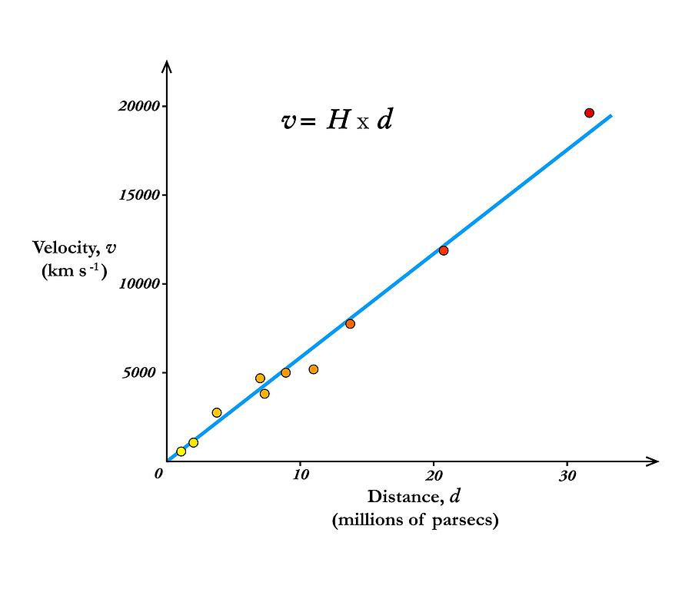

$$v=H_{0}D$$

$$v=recessional velocity (m s^{-1})$$
$$H_{0}=Hubble constant=2.29×{10}^{-18} s^{-1}$$
$$D=proper distance from galaxy to observer (m)$$

- Hubble constant is not a true constant, it varies over time but is theoretically a constant across the universe at any given point in time

Interpreting Hubble’s Law
- What does it mean that all distant galaxies are moving away from us and that the further from us they are, the faster they are moving away?
- Cannot be explained by saying all stars are exploding outwards from us – would expect all distant galaxies to be moving away at the same speed
- Cannot be explained by saying all stars are exploding out from a point distant to us – would not expect a linear relationship in all directions
- Can be explained by saying that space itself is expanding – all galaxies are effectively moving away from each other, the further apart they are, the faster they are effectively moving apart
- Think of points on the surface of a balloon as it is inflated – the rubber (space) expands causing the points to become further apart even if they are not moving across the rubber (through space) themselves

Implications of Hubble’s Law
- Space itself is expanding
- Tracking backwards through time there is a point where space would contract back to a singularity – age of the universe
- Expansion of space out from some beginning referred to as the Big Bang theory
- the Big Bang is not a conventional explosion – does not require a center of the universe – universe may well be infinite in extent

Age of the universe from Hubble constant
- Any distant galaxy is believed to have previously been with us in the singularity, if we know how fast it is moving away and how far away it is, we should be able to determine how long it has been moving
$$v=\frac{s}{t} v=H_{0}D$$
$$\frac{s}{t}=H_{0}D$$
$$\frac{1}{t}=H_{0}$$
$$t=\frac{1}{H_{0}}$$

- So, the age of the universe can be found as the inverse of the Hubble constant (be careful with units)
- Limitation – the Hubble constant is not truly a constant, should account for increasing rate of expansion
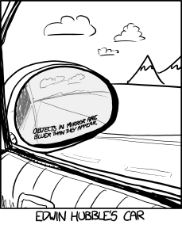
Units for Hubble ‘constant’
- SI units are s⁻¹ but more commonly given as km s⁻¹ Mpc⁻¹
- Demonstrate that 70 km s⁻¹ Mpc⁻¹ ≈ 2.29 x 10⁻¹⁸ s⁻¹

Big Bang Theory development timeline
- 1912 Vesto Slipher recognizes spectral shift in distant stars - determines that distant spiral galaxies are receding from the Earth
- 1915 Albert Einstein’s theory of General Relativity only works for either an expanding or contracting universe – Einstein thinks this is an error, begins looking for a way to adjust it to a static universe
- 1927 Georges Lemaître (catholic priest/professor of physics) suggests that expanding universe could be traced back to an originating single point
- 1929 Edwin Hubble demonstrates the relationship between recession velocity and distance for distant galaxies
- 1931 Georges Lemaître suggests hypothesis of the primeval atom – universe begins with the ‘explosion’ of a ‘primeval atom’ – start of the Big Bang theory
- 1931 Einstein abandons attempts to force General Relativity to fit a static universe
- 1948 Bondi, Gold and Hoyle suggest that while the universe is undeniably expanding there is new matter coming into existence maintaining a constant density – Steady-state model
- 1948 Alpher and Herman recognize that there should be radiation left over from early in the Big Bang which should now be stretched due to the expansion of space to microwave radiation – this radiation should be uniformly distributed throughout space
- 1964 Penzias and Wilson are trying to study microwave radiation from space but their antenna picks up annoying background signal from all directions – assume it is an error in their equipment – Robert Dicke who had independently come to the same conclusions as Alpher and Herman hears of their trouble and recognizes the background signal for what it is – Cosmic Microwave Background Radiation – evidence supporting the Big Bang theory – death-knell for Steady-state model

Rival theories

Big Bang theory (1931-present) | ‘modern’ Steady-state model (1948-1970s)
Expanding universe: space is expanding between galaxies

Isotropic universe: universe has no preferred orientation – looks the same viewed in/from all directions
Homogenous universe: even distribution of matter through the universe at the large scale – looks the same in all places

Universal laws of physics: physical constants and laws are the same throughout the universe

13.8 billion year old evolving universe: space, time and maybe even the laws of physics come into existence at a specific point in time, all matter came into being very early after the Big Bang, density of matter in the universe decreasing as space expands, allows for an end of the universe | Eternal universe: no beginning or end – looks the same at all times, new matter created constantly between galaxies to maintain density of matter in the universe

These tenets should not be taken as fact per se, they are the current assertions, but some research is showing little hints that things may not be quite as simple as this – for the moment the Big Bang theory remains our best theory by far

Evidence for the Big Bang

Expansion of space
- Red-shift of distant galaxies, degree of red-shift increasing with distance – expanding space
- If space is expanding, tracing it back through time would lead to a point where all matter and space was together in a singularity

Observations of galaxy formation and evolution and the distribution of large-scale cosmic structures
- detailed observations of the shape and distribution of galaxies and quasars agree with predictions of the Big Bang Theory
- galaxies of different ages appear notably different (not compatible with steady state model)

Cosmic microwave background radiation
- Early Universe should have been filled with high energy radiation matching a high temperature blackbody spectrum
- The radiation should still be present in the universe but with its wavelength increased by the expansion of space so it should now match a lower temperature blackbody spectrum
- The match of the data to the theory is essentially perfect
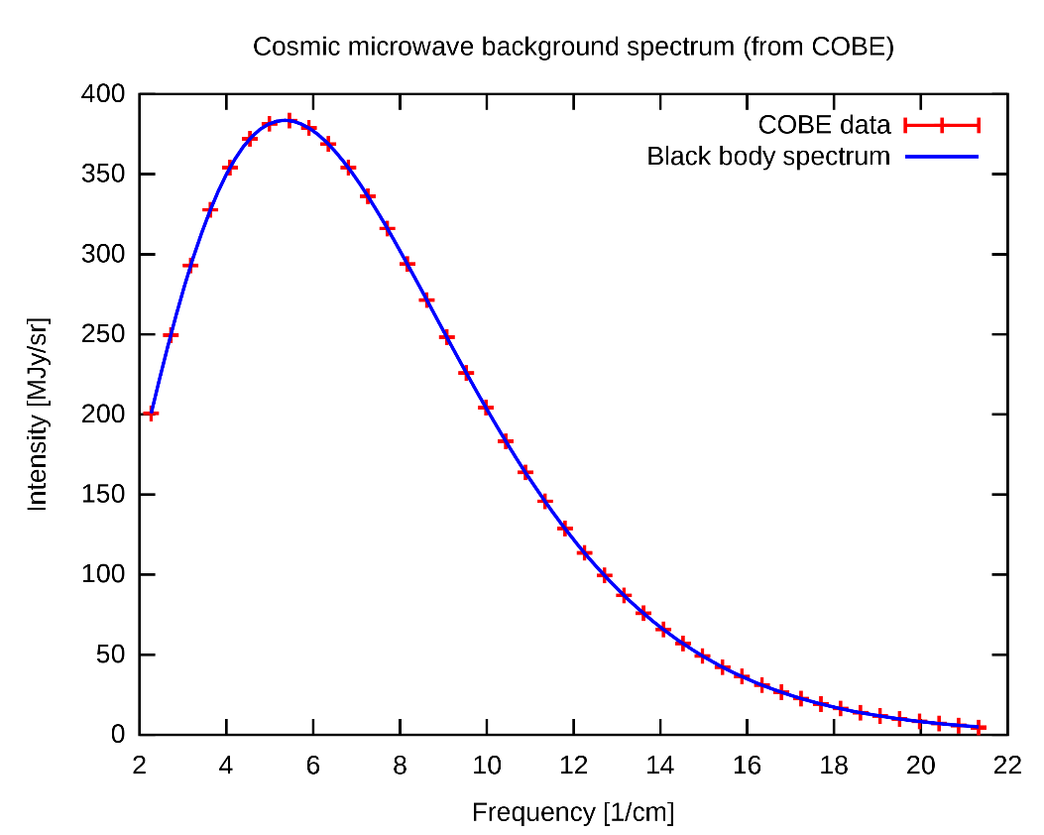
- The graph to the right shows the theory in blue and high precision measurements of CMBR in red – the error bars for the measurements are much too small to be visible on the graph even if the graph were enlarged

Relative abundances of light nuclei
- the Big Bang Theory suggests that early in the universe protons and neutrons were formed and were then able to undergo reactions to form isotopes of hydrogen, helium and lithium – nucleosynthesis
- This would only have occurred over a short timespan (~20 minutes), once the universe was cool enough for deuterium to be stable but while it was still hot and dense enough for fusion reactions to occur at a significant rate
- This leads to very specific predictions about the ratios of the abundance of these isotopes in the universe – relative to H-1 (⁴He/H, ³He/H, ²H/H and ⁷Li/H)
- Our best measurements of these ratios agree reasonably well with these predictions and there’s no particular reason they should without the Big Bang Theor
Possible futures of the universe
- Space is expanding but gravity could stop it
- if the density of matter in the universe is high enough (>10 H atoms per m³) then space has positive curvature, gravity should be able to slow and then reverse the expansion of the universe – Big Crunch
- If the density of matter is t0o low (<10 H m⁻³), then space has negative curvature, gravity will slow the expansion but never stop it – Big Freeze
- If the density of matter is the critical density then space has zero curvature, the expansion will stop after an infinite amount of time – Big Freeze
- Our best measurements of the density of matter/curvature of the universe suggests it is flat – so the expansion of space should be slowing

- However, the expansion seems to be accelerating and this is thought to be caused by dark energy
- Dark energy remains mysterious but can be thought of as fundamental energy of space that exerts a negative gravitation
- As the universe expands the density of matter decreases but the density of dark energy would remain more or less the same – accelerating expansion

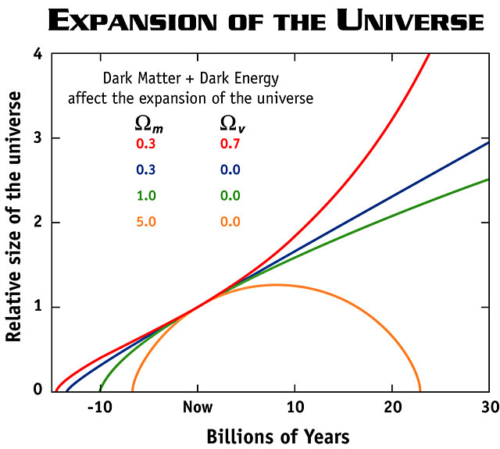
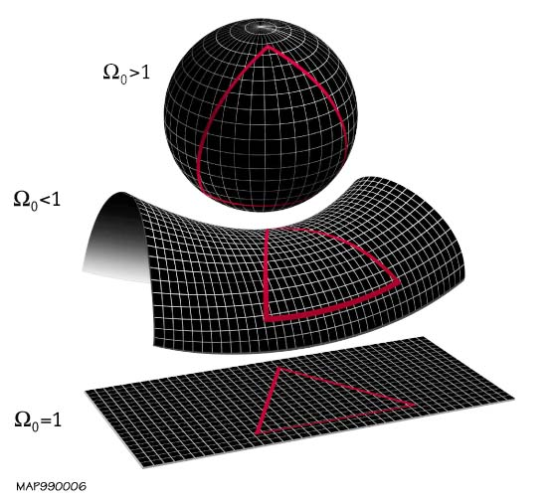

Big Freeze
- Given the accelerating expansion the most likely scenario for the end of the universe is the Big Freeze:
  - Space between cluster of galaxies will grow at increasing rate
  - Supplies of gases need to form stars will deplete
  - Existing stars will run out of fuel and cease to shine
  - Universe will grow darker
  - If protons are unstable then stellar remnants will disappear
  - Eventually even black holes will evaporate through Hawking radiation
  - The universe will approach a uniform temperature – no work will be possible

Universe Revision

- All distant stars are seen to be receding from the Earth, does this mean we are at the centre of the universe? Explain your answer.
- Does the universe have a centre? Explain your answer.
- Estimate the age of the universe from a value of the Hubble constant of 70 km s⁻¹ Mpc⁻¹.
- Briefly explain the evidence that supports the Big Bang theory.
- Contrast the Big Bang theory with the Steady State theory.
- A star, Proxima Centauri, is 4.35 light years from Earth.
  - When you see this star in the night sky, when did that light originate from the star. Explain.
  - How far is Proxima Centauri form Earth in km?
  - If you could travel at 1/10 the speed of light, how long would it take to reach it?
  - How long would it take in a spaceship travelling 25 000 kms⁻¹?
- A galaxy is observed to be receding at 40 000 km s⁻¹.
  - How far away is the galaxy if H0 = 70 km s⁻¹ MPc⁻¹?
  - Determine the red shift that would occur for the spectral line 369.5 nm for elements on earth in the galaxy’s spectrum.
  - Calculate the new wavelength of the red-shifted spectral line.
- How far is 1 parsec in km?
- The diameter of our Milky Way galaxy is 10⁵ light years.
  - What is its diameter in parsecs?
  - How many years would light take to travel across the diameter of our Milky Way galaxy?

Revisions solutions

- No, if we were simply the centre of the universe, we would expect all distant stars to be receding at the same velocity, instead we observe a linear relationship between distance and recessional velocity which cannot be explained by us being at the centre of a conventional explosion.
- Probably not, our best understanding to date suggests that the universe is most likely infinite so will not have a centre.
- T = 1/Ho derive
T = $\frac{1}{70}kms-1Mpc-1= \frac{1 s Mpc}{70 km}= \frac{3.09 x {10}^{19}}{70}s=4.414 x {10}^{17} s=1.40 x {10}^{10}yr$

- The linear relationship between distance to a star and its recessional velocity is best explained by the expansion of space which suggest that back in time space expanded out from a singularity.
The Big Bang theory made a very specific prediction that the universe should be filled by radiation emitted soon after the Big Bang that has since been stretched to microwave radiation. This cosmic microwave background radiation was later discovered with a spectrum in excellent agreement with the prediction.
The relative abundances of light isotopes (H, He & Li) line up well with predictions made by the Big Bang theory and there is no other reason they should.
Galaxies of different ages appear different which lines up well with the Big Bang theory’s idea of an evolving universe.
- The Big bang theory describes a universe that changes over time with the average density of matter over the universe decreasing as space expands. The Steady State Model describes a universe that essentially does not change over time, with new matter coming into existence to maintain a constant average density of matter over the universe as space expands.

  - 4.35 years ago, a light year is the distance light travels in a year so the distance in light years to an object is how far back in years the light left the object
  - S = v x t = 3 x 10⁸ x 4.35 x 365 x 24 x 3600 = 4.12 x 10¹³ km
Or: 4.35 x 9.46 x 10 ¹² = 4.12 x 10¹³ km
  - t = s/v = 43.5 yrs
  - t = 4.115 x 10¹⁶/25 000 x 10³ = 1.646x 109 s = 52.2 yrs

- S = v/H0 = 40 0000 kms⁻¹/70 km/sMpc⁻¹ = 571.42 MPc = 571.42 x 3.09 x 10¹⁹ km
= 1.77 x 10²² km
- Change in wavelength = $=\frac{40 000 x {10}^{3}}{3 x {10}^{8}}x 369.5 x {10}^{-9}=4.93 x{10}^{-8}$m
- $wavelength=369.5+49.2 nm=419 nm$

- Sin (1/3600) = 1.5 x 10¹¹/d d = 3.09 x 10¹⁶m = 3.09 x 10 ¹³ km
Or: 1 pc = 3.09 x 10 ¹³ km (conversion sheet)

  - What is its diameter in parsecs?
D = 10⁵/3.26 x 10⁶ = 0.03067 Mpc = 3.07 x 10⁴ pc
  - How many years would light take to travel across the diameter of our Milky Way galaxy?
10⁵ years, a light year is the distance light travels in 1 year.

High energy particle accelerators
- Mathematical modelling can make quite specific predictions about high energy systems – difficult to test in a laboratory
- Particle colliders attempt to test these predictions by accelerating particles to close to the speed of light and then colliding them with other particles head on
- The total energy of the particles in a collision will be conserved as mass and kinetic energy
- With enough energy, collisions can create particles with more mass than that of the initial particles

Large Hadron Collider (LHC)

“Despite my resistance to hyperbole, the LHC belongs to a world that can only be described with superlatives. It is not merely large: the LHC is the biggest machine ever built. It is not merely cold: the 1.9 kelvin (1.9 degrees Celsius above absolute zero) temperature necessary for the LHC’s superconducting magnets to operate is the coldest extended region that we know of in the universe—even colder than outer space. The magnetic field is not merely big: the superconducting dipole magnets generating a magnetic field more than 100,000 times stronger than the Earth’s are the strongest magnets in industrial production ever made.
And the extremes don’t end there. The vacuum inside the proton-containing tubes, a 10 trillionth of an atmosphere, is the most complete vacuum over the largest region ever produced. The energy of the collisions are the highest ever generated on Earth, allowing us to study the interactions that occurred in the early universe the furthest back in time.”
Lisa Randall, 2011

- The LHC accelerates protons to 0.999 999 99c, giving them 6 500 GeV of energy, allowing for collisions of 13 000 GeV
- Protons normally have a mass corresponding to 0.9 GeV of energy, so these collisions include roughly 7000 times the energy in 2 protons allowing for the creation of much more massive particles
- Head on collisions such as this allow for more of the energy to become mass than possible by colliding with a stationary target

Future Circular Collider (FCC)
- Proposed to be ready for operation in the late 2050s
- Aiming for energies of 100 TeV compared to 6.5 TeV from the LHC

Example
- Protons in a small particle accelerator travel through a horizontal circular track of 38.4 cm diameter. The track is exposed to a vertical magnetic field of 0.398 T. Determine the velocity of the protons.

Particle Physics
- By the early 1960s experiments with particle accelerators had discovered more than 100 sub-atomic particles such as the kaon, the lambda and the omega
- This enormous collection of particles were all thought to be fundamental, indivisible
- In 1964 Gell-Mann and Zweig proposed that many of these particles weren’t fundamental but that they were composed of differing combinations of smaller particles - quarks
- It is almost impossible to observe lone quarks so the theory was initially contentious, but many experiments continue to confirm and develop the theory

Fundamental particles of matter
- It was discovered that combinations of just 6 quarks could explain a very large number of the particles - e.g. a proton is two up quarks and one down quark
- These particles, made of two or more quarks are known as hadrons
- Hadrons could not quite account for all particles – there were other particles that did not experience the strong force – these are known as leptons and include electrons
- All matter is made of combinations of these 12 fundamental particles – the matter we commonly interact with uses just up quarks, down quarks and electrons

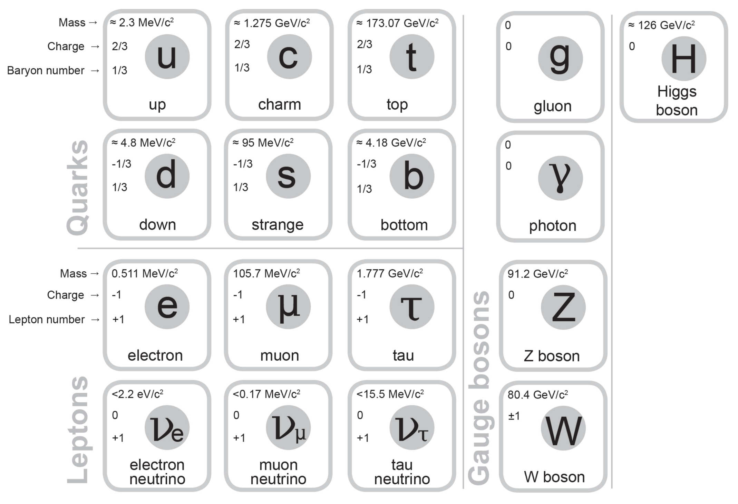

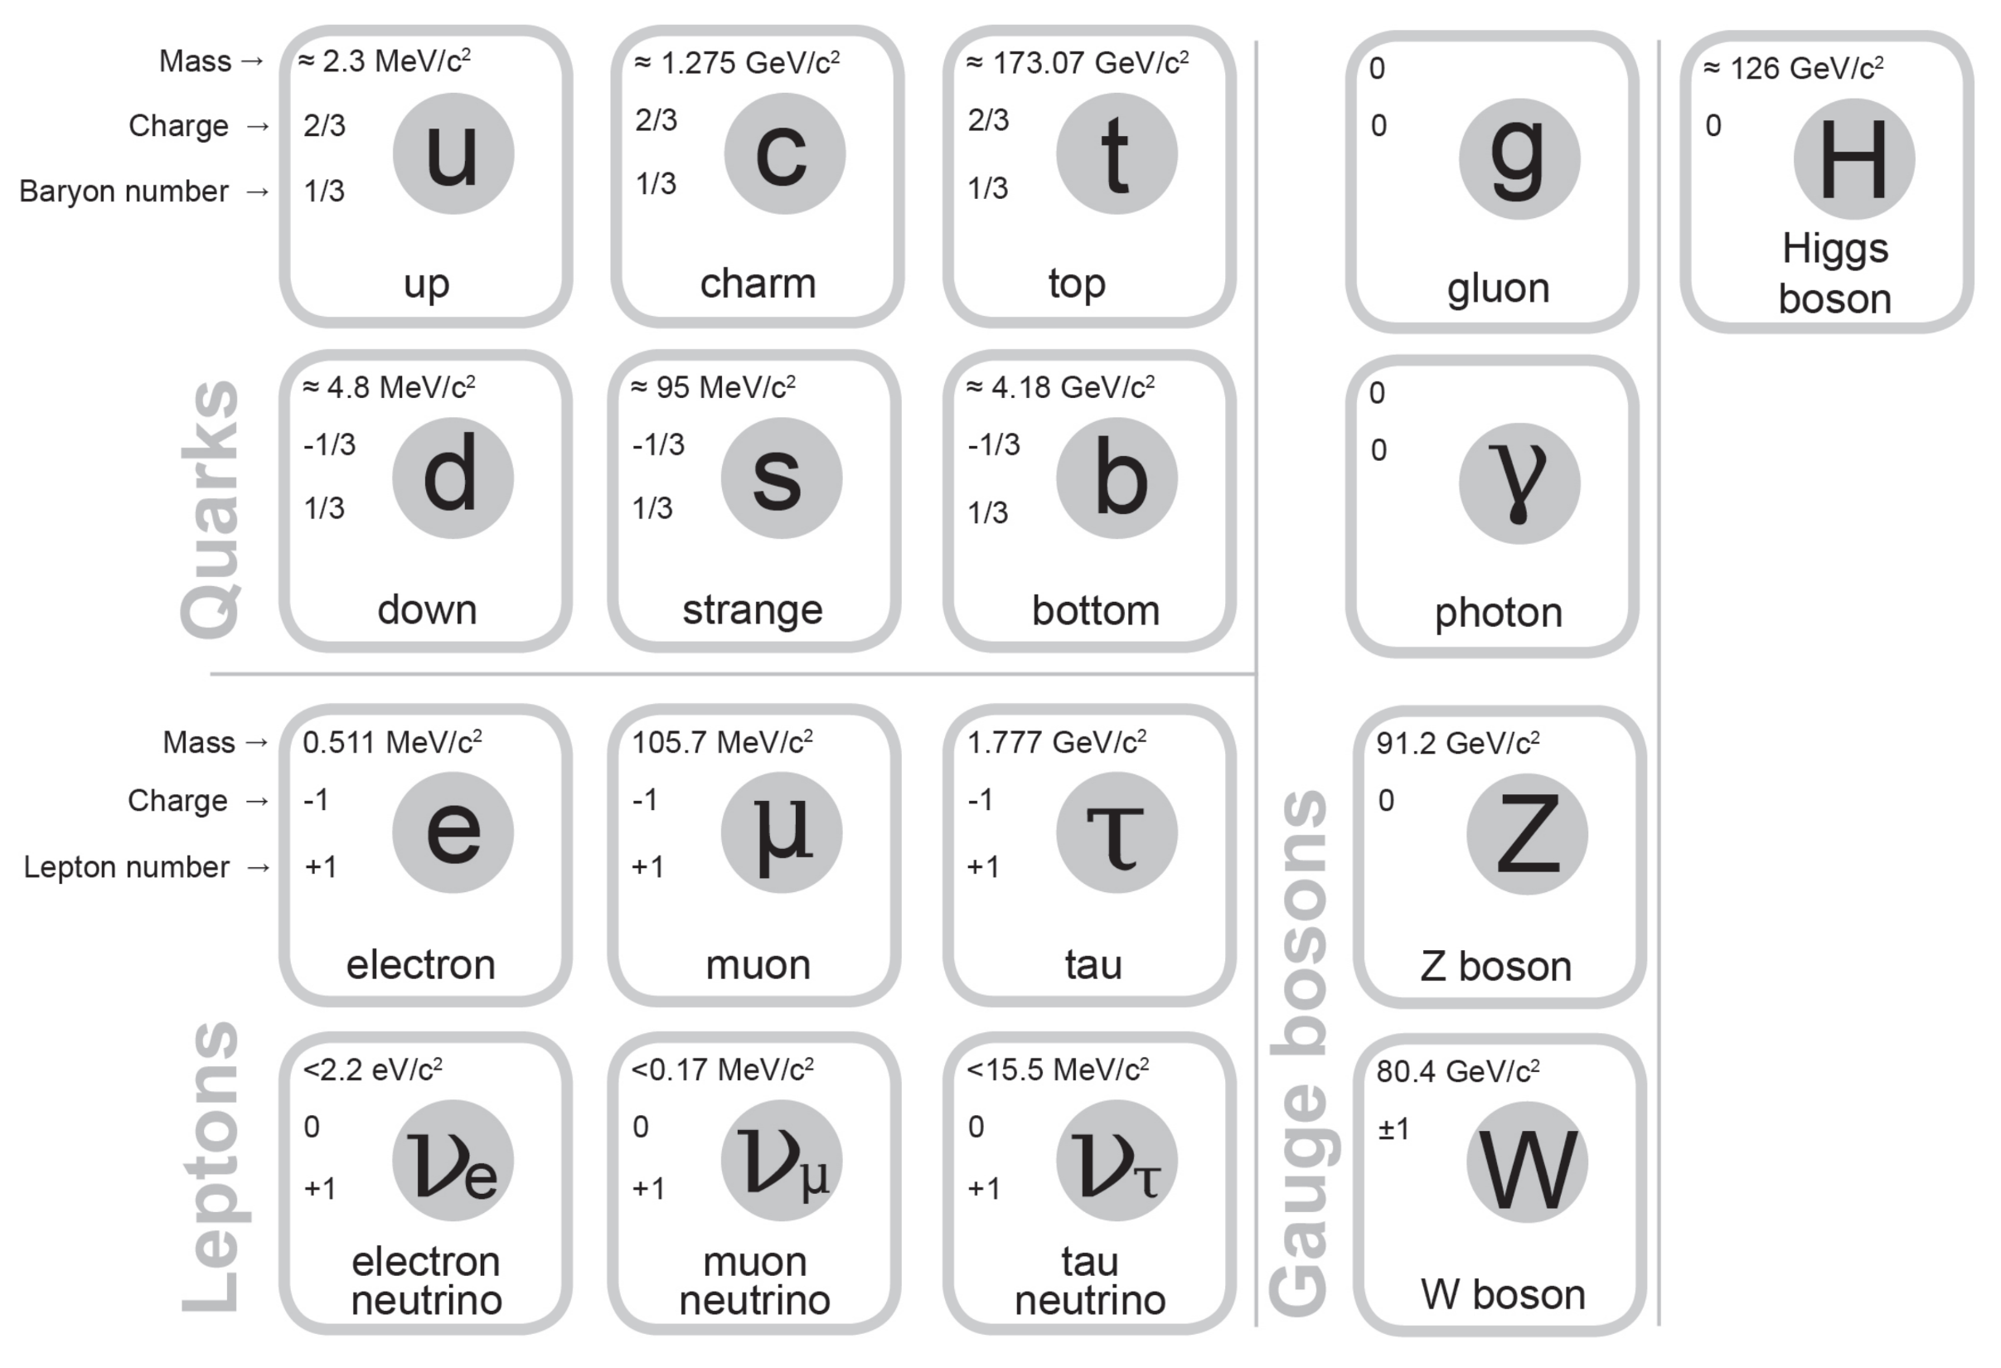
Fundamental forces
- Experiments with particle accelerators also developed our understanding of three of the four fundamental forces – electromagnetism, the strong force and the weak force
- These forces are understood to be mediated by the exchange of force carrier particles known as gauge bosons
- The strong force is mediated by gluons (and mesons)
- Electromagnetism is mediated by photons
- The weak interaction is mediated by W⁺, W⁻ and Z⁰ bosons
- Gravity may be mediated by a hypothetical graviton but there is currently no quantum theory of gravity

Extension - Virtual Particles
- Quantum field theory suggests the universe is filled with multiple
overlapping fundamental fields
- The fundamental particles are then excitations in these fields so an electron would be an excitation of the electron field – we perceive these excitations as particles at most scales (wave-particle duality)
- The gauge bosons as force carriers typically occur as virtual particles
- Virtual particles are temporary excitations and cannot be directly observed – they transfer energy, charge and/or momentum between particles
- Ordinary (non-virtual) photons are common in everyday conditions, ordinary versions of the other carrier particles are not

Higgs boson
- The Higgs field is responsible for mass – the Higgs boson is the excitation of the Higgs field and is significant because it is taken of proof of one of the key predictions of the standard model - as proof of the existence of the Higgs field
- It can be thought of as a carrier particle, like the other fundamental bosons, but it is not exactly a force carrier because mass is not a force – it is a boson, but not a gauge boson (gauge bosons are vector bosons while the Higgs boson is scalar – forces have direction while mass does not)

The Standard Model
- This leads to the Standard Model – we have a set of fundamental particles that are responsible for all matter and force (apart from gravity)

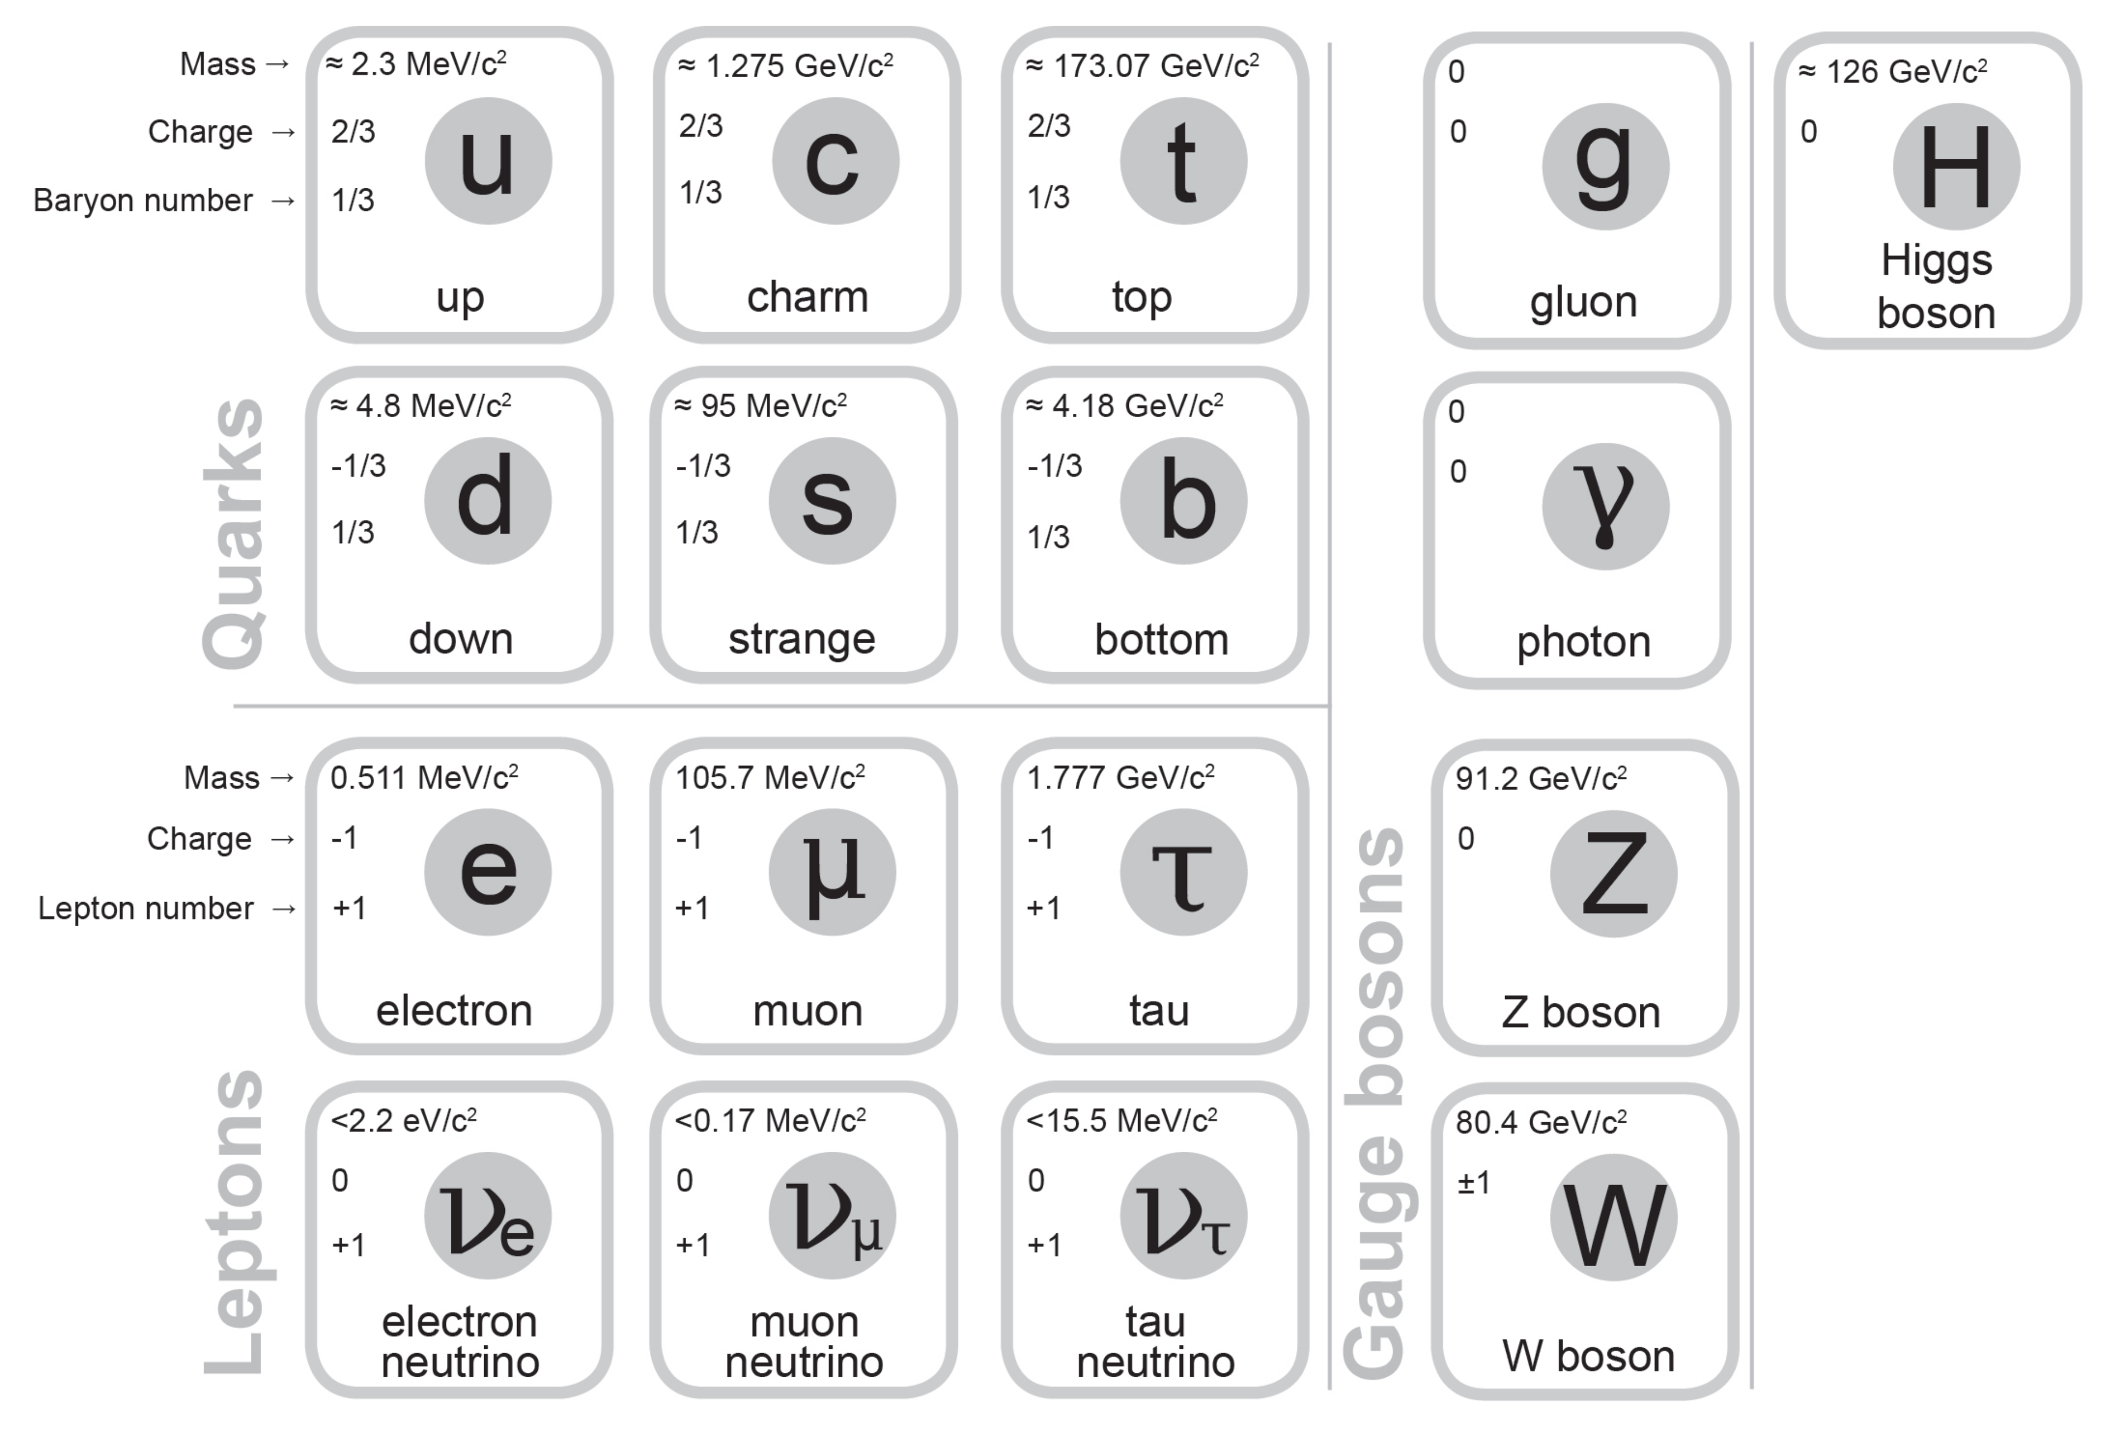

- Our version of the table lists mass and charge for each particle, baryon number for the quarks, and lepton number for the leptons
- Mass is given as a quantity of energy/c² we need to be able to convert that to kg
- Charge is fractional for quarks
- Note that there are two W bosons, one with a charge of +1 and one with a charge of -1

Antimatter
- Matter and antimatter are equal opposites that cancel out – annihilate
- Antimatter is every bit as ‘real’ and observable as matter (just rarer)
- Antimatter particles are ‘twins’ of matter particles with the opposite electric charge (except for uncharged particles)
- When a matter particle meets its antimatter twin, they are both destroyed releasing energy (typically as photons)
- All quarks and leptons have antimatter twins, photons and gluons do not, W⁺ and W⁻ are each others' antiparticles while Z⁰ is its own antiparticle
- Note that antimatter is a completely separate concept from dark matter which refers to hypothetical matter that we cannot directly observe

- Shortly after the Big Bang, slightly more matter was created than antimatter, the antimatter mutually annihilated with much of the matter, so our universe is matter dominated and very little antimatter exists at any point in time
- This asymmetry remains a major unsolved question in physics
- We have successfully created antihydrogen and antihelium using particle accelerators but nothing more complicated
- It is possible to create particles from ‘empty space’ as long as you create both the matter and antimatter particle together
$$0=1+-1$$
- This can occur spontaneously and is one example of virtual particles as the two particles typically recombine quickly
- In certain circumstances (e.g. Hawking radiation) it can be possible for these virtual particles to become ordinary particles

Electron-positron annihilation
- When antimatter-matter pairs annihilate conservation laws must be upheld.
- For electron-positron annihilation this includes conservation of charge, total energy, linear and angular momentum, and lepton number
- If you take a frame of reference in which the net linear momentum of the electron and positron are zero, we can see that creating a single photon is impossible as it would have linear momentum violating conservation of linear momentum
- Electron-positron annihilation will therefore always create two photons travelling in opposite directions to conserve linear momentum

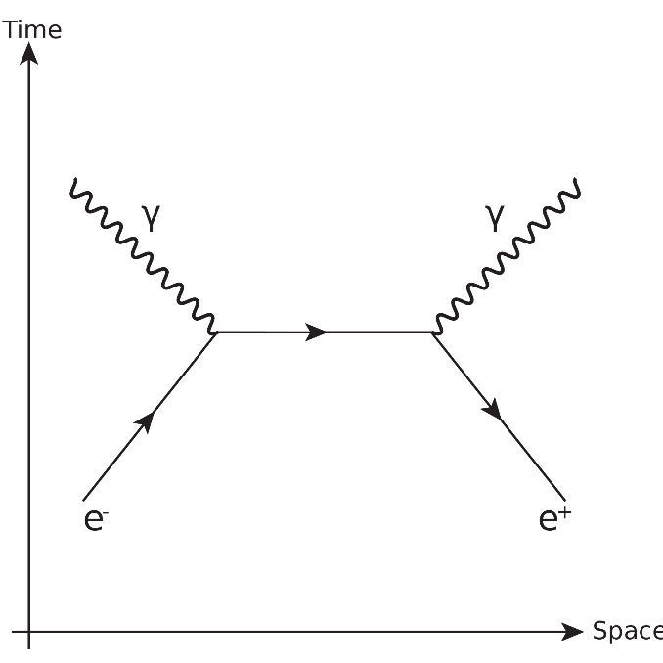
Baryon number
- All quarks have a baryon number of 1/3 (antiquarks have a baryon number of -1/3)
- Baryon number is an additive number that is strictly conserved
- Hadrons (particles made of quarks) must either have a baryon number of 1, 0, or -1
- A hadron with a baryon number of 1 is called a baryon and would typically be made of 3 quarks
- A hadron with a baryon number of 0 is called a meson and would typically be made of 1 quark and 1 antiquark
- A hadron with a baryon number of -1 is called an antibaryon and would typically be made of 3 antiquarks

Examples
- Protons
  - Determine the mass (in kg) and charge of a particle made of 2 up quarks and 1 down quark.

  - State the mass (in kg) and charge of a proton.

  - Are these the same particle?

- Neutrons
  - Determine the mass (in kg) and charge of a particle made of 2 down quarks and 1 up quark.

  - State the mass (in kg) and charge of a neutron.

  - Are these the same particle?

- For each of the following quark combinations state the:
    - Charge
    - Baryon number
    - Whether it is possible or not
    - If possible, the type of particle (baryon, meson or antibaryon)
- $ut\overline{s}$

- $dsc$

- $b\overline{t}$

- $\overline{u}\overline{c}\overline{b}$

- $uudc\overline{c}$

Extension - Colour charge

- Baryon number is closely related to concepts known as colour charge and colour confinement
- Quarks have electric charge but also ‘colour’ charge
- Electric charge refers to two opposite charges that cancel out which we label positive and negative
- In contrast, colour charge refers to three mutually cancelling charges – labelled red, blue, and green, the 3 primary colours of light that ‘cancel’ together to white
- Colour charge has literally nothing to do with light or colour in the normal sense, we just needed 3 things that together cancel out
- Antiquarks have colour charge as well but take on the colours anti-red, anti-blue, and anti-green (cyan, yellow, and magenta respectively)
- Colour confinement refers to the fact that hadrons must be colour neutral (white) at temperatures below about 1x10¹² K
- Colour confinement means that lone quarks would normally not exist
- e.g. 3 quarks, 1 red, 1 blue and 1 green can combine to form a white hadron (baryon)
- e.g. 1 red quark and 1 antired antiquark could combine to form a white hadron (meson)
- Importantly, a given quark is not locked to a specific colour charge e.g. an up quark can be red, blue or green and can change colour during its lifespan
- Gluons also interact with colour charge as colour charge is related to the strong force
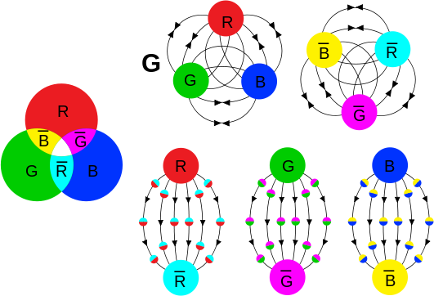

Leptons
- All leptons have a lepton number of +1 (anti-leptons have a lepton number of -1)
- Lepton number is an additive number that is conserved in reactions, e.g.
$$\overline{ν}+n→p+e^{-}$$
- is not possible because the antineutrino on the left has a lepton number of -1 while the electron on the right has a lepton number of +1
$$\overline{ν}+p→n+e^{+}$$
- on the other hand, can occur because the antineutrino and positron both have a lepton number of -1

Lepton flavour conservation
- Each lepton family (e, μ & $\text{τ}$ ) has their own lepton family number that must be conserved separately in reactions

Particle | Electron number (L_{e}) | Particle | Muon number (L_{μ}) | Particle | Tauon number (L_{𝛕} )
$$e^{-}$$ | 1 | $$μ^{-}$$ | 1 | $$τ^{-}$$ | 1
$$ν_{e}$$ | 1 | $$ν_{\text{μ}}$$ | 1 | $$ν_{\text{τ}}$$ | 1
$$e^{+}$$ | -1 | $$μ^{+}$$ | -1 | $$τ^{+}$$ | -1
$${\overline{ν}}_{e}$$ | -1 | $${\overline{ν}}_{\text{μ}}$$ | -1 | $${\overline{ν}}_{\text{τ}}$$ | -1

- For example, when a muon decays into an electron, there must also be an electron antineutrino and a muon neutrino created
$$μ^{-}→e^{-}+{\overline{ν}}_{e}+ν_{μ}$$
- The electron antineutrino conserves the change in electron number from the creation of the electron and the muon neutrino conserves the muon number from the loss of the muon

Example
- Determine if lepton number would be conserved by a muon decaying into an electron, a muon neutrino and an electron antineutrino. Show full working.

- Determine if lepton number would be conserved by a tauon decaying into a muon, a muon neutrino and a tau neutrino. Show full working.

Complex particle interactions

- Considering conservation of charge, baryon number and lepton number determine if the reaction below is possible. A proton decays to form a neutron, positron and electron neutrino. Show full working.

- Considering conservation of charge, baryon number and lepton number determine the missing fundamental particle from the reaction below. A tauon decays to form a tau neutrino, a down quark and an unknown. Show full working.

Fundamental forces

 | Strong | Electromagnetism | Weak | Gravity
Range: | Short | Long (inverse square) | Short | Long (inverse square)
Strength: | Strongest | Strong | Weak | Weakest
Carrier: | Gluons (and mesons) | Photons | W⁺, W⁻ and Z⁰ bosons | Gravitons?
Responsible for: | Binding quarks together to form hadrons  Binding hadrons together to form nuclei | Binding electrons to nuclei to form atoms, binding atoms together to form molecules/lattices - chemistry, electronics, light | Mediating beta decay and other interactions including neutrinos | Forming stars, planets, black holes, galaxies etc.

Extension - Feynman diagrams

- Diagrams represents quantum field theory processes in terms of particle interactions – pictorial representations of advanced mathematics
- Time is typically drawn with time progressing upwards but sometime shown with time progressing to the right
- Shows interactions over time typically including incoming particles at the beginning, outgoing particles at the end and temporary virtual particles in between
- Quarks and leptons are drawn as arrows with the direction pointing with the progression of time – antimatter particles are drawn as if moving backwards through time
- Don’t show much in the way of spatial information

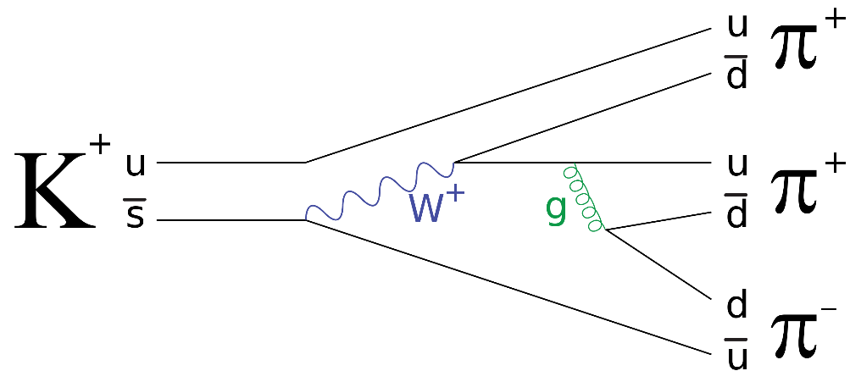

The strong force – gluons (and mesons)
- The strong force bonds quarks together into hadrons e.g. protons and neutrons
- The strong force between nucleons is mediated by gluons which have no mass or electric charge but do carry colour charge
- The strong force also bonds neutrons and protons together to form nuclei but this is mediated by mesons rather than gluons
- Gluons and mesons both carry a colour and an anti-colour
- Gluons do not have antimatter versions (could be thought of as a matter-antimatter hybrid particles)

g (green-antiblue)
u (green)
d (green)
u (blue)
d (blue)

The weak interaction - W⁺, W⁻ and Z⁰ bosons
- The W and Z bosons mediate the weak force or interaction
- W± bosons mediate the emission and absorption of neutrinos in processes such as Beta decay transferring electric charge, momentum and/or energy
- Z bosons transfer momentum and/or energy (and spin) in processes such as elastic scattering of neutrinos
- The W and Z bosons have mass unlike photons and gluons

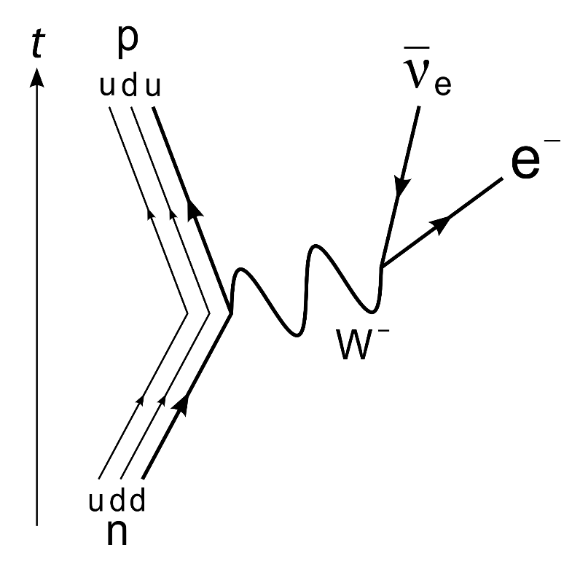

Electromagnetism – photons
- A very wide range of familiar interactions such as electrostatic repulsion are mediated by virtual photons
- The virtual photon transfers energy and/or momentum but no electric charge or colour charge

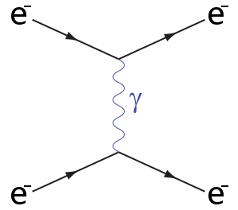

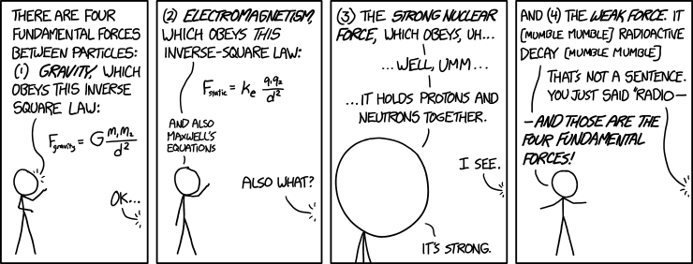

"Of these four forces, there's one we don't really understand." "Is it the weak force or the strong--" "It's gravity."

Combining the Big Bang with the Standard Model
- The Big Bang suggests that in the early universe the density of energy was extremely high
- Particle accelerators let us model extremely high energy situations and investigate particle interactions and stability under those conditions
- Can be thought of as letting us look back in time at what the universe may have been made of under those conditions
- This gives us some insight into the evolution of matter and the universe after the Big Bang

Evolution of forces
- Possible total unification of force (Theory of Everything?)
- Gravity and Electronuclear force (Grand Unification)
- Gravity, Strong and Electroweak forces
- Gravity, Strong, Weak and Electromagnetism

Evolution of matter
- Energy
- Matter-antimatter pair creation of fundamental particles
- Quark-antiquark annihilation, formation of hadrons from remaining quarks
- Formation of light nuclei (H, He, Li) from hadrons
- Lepton-antilepton annihilation
- Formation of neutral atoms from light nuclei and remaining electrons
- Formation of heavier nuclei in stars

Epoch/Event | t | T | Forces | Matter | Other details
Planck | <10⁻⁴³ s | >10³² K | Quantum gravity? | Energy?
Grand unification | <10⁻³⁶ s | >10²⁹ K | Gravity and Electronuclear | Fundamental particles | Matter-antimatter pairs created, slightly more matter created
Electroweak | <10⁻³² s | >10²² K | Gravity, Strong and Electroweak
Quark | 10⁻¹² ~ 10⁻⁶ s | >10¹² K | Gravity, Strong, Weak and Electromagnetism | Quark-gluon plasma | These conditions are the highest energy directly observable in the LHC
Hadron | 10⁻⁶ ~ 1 s | >10¹⁰ K |  | Hadrons form | Quark matter-antimatter annihilation small remainder of matter quarks
Nucleosynthesis | 10 ~ 10³ s | >10⁷ K |  | H, He and Li form | Universe hot enough for fusion but cool enough for H-2 to be stable
Photon | 10 s ~ 370 ka | >4000 K |  | Photons dominate | Lepton matter-antimatter annihilation small remainder of matter leptons
Recombination | 370 ka | 4000 K |  | Neutral atoms form | Electrons combining with nuclei release excess energy as photons now visible as CMBR
Dark ages | 370 ka ~150 Ma | >60 K |  |  | Slight variation in spread of matter allows gravity to form clumps
Star and galaxy formation | ~ 250 Ma | 60 K |  | Heavier elements form | Gravity compresses clumped matter making stars

Standard Model Particle Physics Revision

- Define the following terms
  - baryon
  - hadron
  - meson
  - antibaryon
- Complete the table below and hence determine whether the following reactions are possible. Show full working for charge, baryon number and lepton numbers.
Particle | Composition | Baryon number | Charge
$$Λ^{0}$$ | $$uds$$
$$K^{+}$$ | $$u\overline{s}$$
$$K^{0}$$ | $$d\overline{s}$$
$$K^{-}$$ | $$s\overline{u}$$
$$π^{+}$$ | $$u\overline{d}$$
$$π^{0}$$ | $$d\overline{d}$$
$$π^{-}$$ | $$d\overline{u}$$

  - $p+p→p+Λ^{0}+Κ^{+}$
  - $τ^{-}→υ_{τ}+e^{-}+\overline{υ_{e}}$
  - $Κ^{-}+p→Λ^{0}+π^{0}$
  - $τ^{-}→μ^{-}+υ_{μ}+υ_{τ}$
  - $p+n→p+Λ$
  - $\overline{p}+p→Κ^{-}+Κ^{0}+π^{+}$
  - $τ^{-}→\overline{ν_{τ}}+π^{-}+π^{0}$
  - $Κ^{-}→π^{-}+γ$
  - $μ^{-}→υ_{e}+e^{-}+\overline{υ_{μ}}$
- Calculate the minimum frequency of the photon for the reaction below:
$$γ→e^{+}+e^{-}$$
- Compare the four fundamental forces by strength, range, and carrier particle.
- Give an example of a process mediated by each of the four fundamental forces.
- Briefly outline the steps in creating H-2 from energy after the Big Bang.
- Compare the mass of two up quarks and one down quark in kg to the mass of 1 proton in kg.
- Three elementary particles were fired through a magnetic field at the same velocity, a muon neutrino and two quarks. Their paths are shown to scale relative to each other below.
  - is ‘a’ a charm or an anticharm quark?
x
x
x
x
x
x
x
x
x
x
x
x
x
x
x
x
x
x
x
x
x
x
x
x
x
x
x
x
x
x
x
x
x
x
x
x
x
x
x
x
x
x
x
x
x
x
x
x
x
x
x
x
x
x
x
x
x
x
x
x
x
x
x
x
a
b
c
  - what is ‘b’?
  - what is ‘c’?

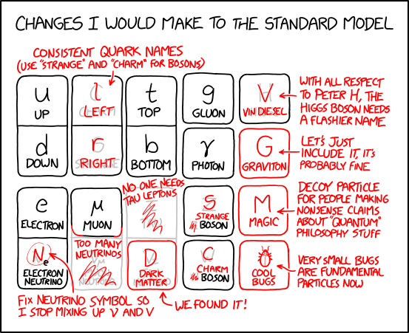

Standard Model Particle Physics Revision Solutions

- Define the following terms
  - baryon: hadron with a baryon number of 1
  - hadron: particles made of quarks
  - meson: hadron with a baryon number of 0
  - antibaryon: hadron with a baryon number of -1

- Complete the table below and hence determine whether the following reactions are possible. Show full working for charge, baryon number and lepton numbers.
Particle | Composition | Baryon number | Charge
$$Λ^{0}$$ | $$uds$$ | 1 | 0
$$K^{+}$$ | $$u\overline{s}$$ | 0 | 1
$$K^{0}$$ | $$d\overline{s}$$ | 0 | 0
$$K^{-}$$ | $$s\overline{u}$$ | 0 | -1
$$π^{+}$$ | $$u\overline{d}$$ | 0 | 1
$$π^{0}$$ | $$d\overline{d}$$ | 0 | 0
$$π^{-}$$ | $$d\overline{u}$$ | 0 | -1

  - $p+p→p+Λ^{0}+Κ^{+}$
$$charge:1+1=1+0+1$$
$$baryon number:1+1=1+1+0$$
$$possible$$
  - $τ^{-}→υ_{τ}+e^{-}+\overline{υ_{e}}$
$$charge:-1=0+(-1)+0$$
$$tau number:1=1+0+0$$
$$electron number:0=0+1+(-1)$$
$$possible$$

  - $Κ^{-}+p→Λ^{0}+π^{0}$
$$charge:-1+1=0+0$$
$$baryon number:0+1=1+0$$
$$possible$$

  - $τ^{-}→μ^{-}+υ_{μ}+υ_{τ}$
$$charge:-1=-1+0+0$$
$$tau number:1=0+0+1$$
$$muon number:0≠1+1+0$$
$$not possible$$

  - $p+n→p+Λ$
$$charge:1+0=1+0$$
$$baryon number:1+1=1+1$$
$$possible$$

  - $\overline{p}+p→Κ^{-}+Κ^{0}+π^{+}$
$$charge:-1+1=-1+0+1$$
$$baryon number:-1+1=0+0+0$$
$$possible$$

  - $τ^{-}→\overline{ν_{τ}}+π^{-}+π^{0}$
$$charge:-1=0+(-1)+0$$
$$tau number:1≠-1+0+0$$
$$not possible$$

  - $Κ^{-}→π^{-}+γ$
$$charge:-1=-1+0$$
$$possible$$

  - $μ^{-}→υ_{e}+e^{-}+\overline{υ_{μ}}$
$$charge:-1=0+(-1)+0$$
$$muon number:1≠0+0+(-1)$$
$$electron number:0≠1+1+0$$
$$not possible$$

- Calculate the minimum frequency of the photon for the reaction below:
$$γ→e^{+}+e^{-}$$

$$m=2×9.11×{10}^{-31}=1.822×{10}^{-30}$$
$$E=mc^{2}=1.822×{10}^{-30}×{\left(3×{10}^{8}\right)}^{2}=1.6398×{10}^{-13}J$$
$$f=\frac{E}{h}=\frac{1.6398×{10}^{-13}}{6.63×{10}^{-34}}=2.47×{10}^{20}Hz$$

alternatively
$$E=2×0.511×{10}^{6}×1.6×{10}^{-19}=1.6352×{10}^{-13}J$$
$$f=\frac{E}{h}=\frac{1.6352×{10}^{-13}}{6.63×{10}^{-34}}=2.47×{10}^{20}Hz$$

- Compare the four fundamental forces by strength, range, and carrier particle.
 | Strong | Weak | Electromagnetism | Gravity
Strength | strongest | weak | strong | weakest
Range | very short | short | infinite | infinite
Carrier Particle | gluon (and mesons) | W and Z bosons | photons | graviton

- Give an example of a process mediated by each of the four fundamental forces.
Strong: formation of hadron from quarks, Weak: beta decay, Electromagnetism: electrostatic attraction, Gravity: formation of star from nebula

- Briefly outline the steps in creating H-2 from energy after the Big Bang.
- energy becomes matter and antimatter, both quarks and leptons
- quarks join to form protons (uud) and neutrons (udd)
- protons and neutrons undergo nuclear fusion to form H-2 nucleus
- electrons combine with nucleus to form neutral H-2 atom

- Compare the mass of two up quarks and one down quark in kg to the mass of 1 proton in kg.
uud has very close to 1% the mass of a proton (2.3+2.3+4.8)x10⁶x1.6x10⁻¹⁹/(3x10⁸)²=1.67x10⁻²⁹, the rest of the mass of the proton is from the other energy in the proton, energy associated with gluons and other virtual particles

- Three elementary particles were fired through a magnetic field at the same velocity, a muon neutrino and two quarks. Their paths are shown to scale relative to each other below.
  - is ‘a’ a charm or an anticharm quark?
x
x
x
x
x
x
x
x
x
x
x
x
x
x
x
x
x
x
x
x
x
x
x
x
x
x
x
x
x
x
x
x
x
x
x
x
x
x
x
x
x
x
x
x
x
x
x
x
x
x
x
x
x
x
x
x
x
x
x
x
x
x
x
x
a
b
c
a must be positive so it is a charm quark
  - what is ‘b’?
b must be electrically neutral so is the muon neutrino
  - what is ‘c’?
c is negatively charged because of the direction it
curves, it’s radius is 6.5 times the radius of a, so
given that r=mv/qB, it must be larger mass and/or
smaller charge by a combined factor of 6.5, a bottom
quark is half the charge (doubling the radius) and 3.3
times the mass (multiplying radius by 3.27), leading to
the right combined factor, so it must be a bottom quark

